 VINOD SIR’S GROUP TUTION

MARKS: 16 MATHS-II TIME: 1 Hr. 30 Mins.

Q. 1: Identify, with reason, which of the following are Pythagorean triplets. [2]
1. (24, 70, 74) 2. (10, 24, 27)

Q. 2: 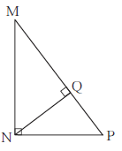 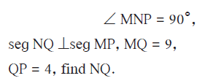 [2]

Q. 3: Find the side and perimeter of a square whose diagonal is 10 cm. [2]

Q. 4: 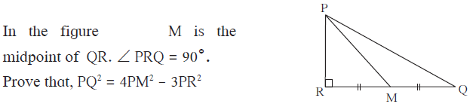 [2]

Q. 5: Walls of two buildings on either side of a street are parellel to each other. A ladder 5.8 m long is placed on the street such that its top just reaches the window of a building at the height of 4 m. On turning the ladder over to the other side of the street , its top touches the window of the other building at a height 4.2 m. Find the width of the street. [3]

Q. 6: In triangle ABC, AB = 10, AC = 7, BC = 9 then find the length of the median drawn from point C to side AB [2]

Q. 7: 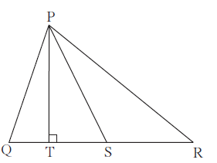 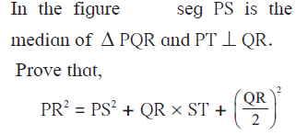 [3]

